Start with Hello T-Shirt Order Form
Cost $10
Turn in order forms and payment to Mrs. Borders in the media
or at lunches by 9/10 at 2 pm.

Student Name _______________________________________ Student #_________________________

Size: _____Youth Medium ____Youth Large ____Adult Small
_____Adult Medium ______Adult Large ____Adult XL ______Adult 2XL (add $2)

Color (circle one): Yellow Gray

Payment (circle one): Cash Check (phone # & Driver's License #) Online (must turn in the form)

Student Schedule:
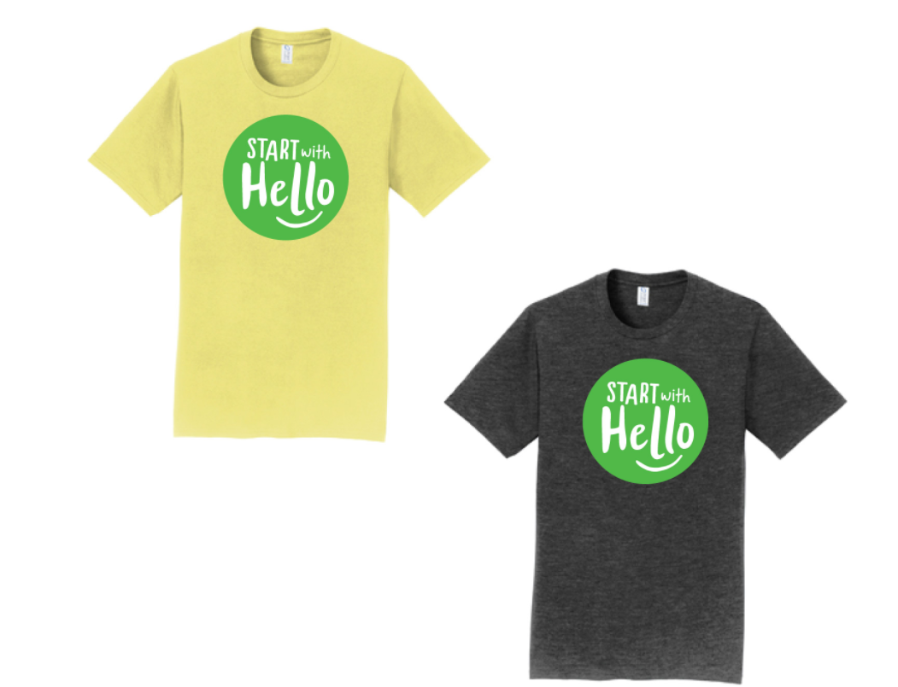
1st period __________________
2nd Period __________________
3rd Period __________________
4th Period __________________
5th Period __________________
6th Period___________________

