Rules of Dress and Appearance 2019-2020
In order to promote an orderly learning environment in our schools while preparing all students for later success in the world of work, the District School Board of Pasco County has established the following guidelines for student dress:
• The principal, or designee, shall determine the appropriateness of dress and appearance in accordance with
the guidelines distributed by the school, school board policy and guidelines contained herein. The principal,
or designee, will make the decision if a student’s appearance meets school and community standards. The
principal’s decision on the appropriateness of dress is final as long as it does not contradict official district
policy listed herein or elsewhere.
• These guidelines are in effect while on any District School Board of Pasco County school or campus, at any
school function or on any school-sponsored transportation.

The following types of clothing, items, accessories and apparel are considered inappropriate for the school environment.
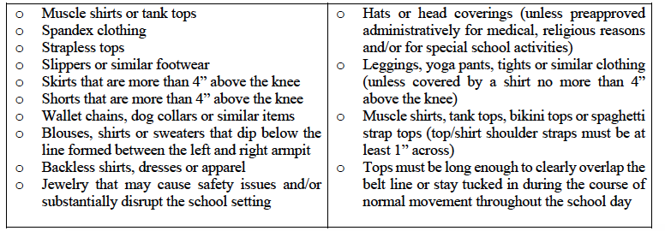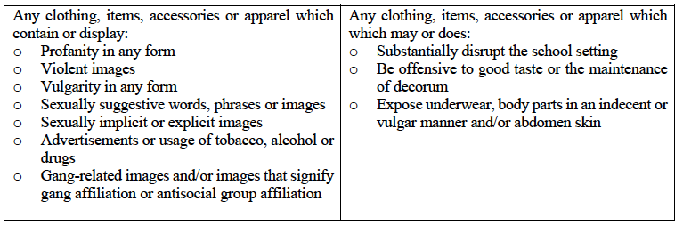
- Offensive designs tattooed or imprinted on the body must be covered.
- Students shall wear shoes for foot protection and hygienic reasons while on school grounds or on school transportation. Slippers are not acceptable.
- If issued, student must be in possession of school badges during all school activities and must present the badge to school officials upon request.
- Schools may not require a student to remove or discipline a student for wearing clothing that depicts a firearm or weapon or expresses an opinion regarding a right guaranteed by the Second Amendment (F.S. 1006.07)
- Clothing depicting violent acts and/or violence remain inappropriate for the school setting.

Violations of these provisions of the dress code are subject to the following consequences as defined by F.S. 1006.07(2)(d1) and F.S. 1006.07(2)(d2) as follows:

- Warning & change clothes
- Warning & change clothes
- Change clothes & 1 day lunch detention
- Change clothes & 1 day lunch ISS
- Change clothes & 2 days lunch ISS
- Change clothes & 1 day after school detention
- Discipline referral.

****Failure to complete any listed intervention/consequence will result in referral.

Students in violation of the dress code:
• Will be required to change into appropriate clothing, contacting the parent/guardian as needed.
• Students may be required to remain in the front office until the above condition is met per principal discretion.
• May receive a discipline referral and receive consequences as appropriate for repeated breaches of the policy.

