MySchool Online Students

(and any other students working from home)
Please follow the log in below to access your account using a SCHOOL COMPUTER:
- Turn on computer.
- Log in using… username: guest
password: guest
Continue through all these steps with your school computer.
If you are working on your own computer, START HERE:
Click on the Google Chrome icon on the bottom/side bar of your computer.
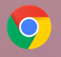
You may also have Safari or Internet Explorer as options to get on to the internet.
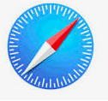
Type in (or copy) the following address (Pasco Middle School Home Page):
https://pms.pasco.k12.fl.us/

Scroll down until you find this red bar/link on the left side. Click here to open.

Sign in to myPascoConnect

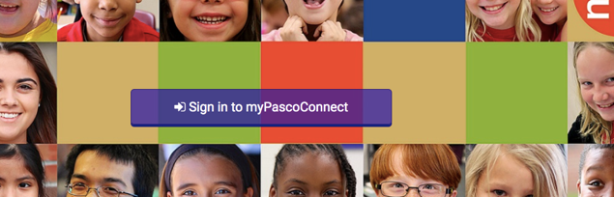

Enter your username and password in the provided field.
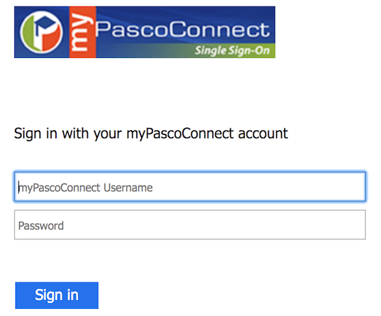

-MyPascoConnect Username is your student/lunch number (6 number digit)
-Password begins with a capital letter, is an English word, ends with a 2-digit number and a symbol. Students should already have received their password; if not, please call the school: 352-524-8400.

Click on “Sign In”

Scroll through your apps until you find the “MyLearning” app. Click to open.

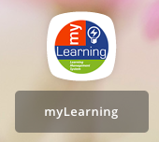

Your Dashboard will show all 6 classes. Click on the box with the name of the class you want to open OR Go to courses under Your Account (blue stripe on left side). Click to open and drag your mouse over the class and release.

You should see all 6 of your classes in MyLearning!

You will automatically be directed to the Home Page for EACH CLASS. Read Announcements right below Home each time you log in to each class!

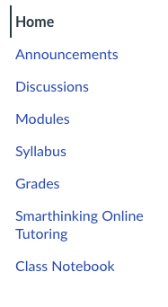
**Zoom links may be found on the Home Page, under Announcements, or under Modules.**

To check for email from your teachers or to contact your teachers, click on INBOX (blue stripe on left side).

REMEMBER: We follow a rotational schedule at Pasco Middle School. Each day begins with a different class/period so print this schedule out or copy it somewhere for easy access. Go to the Pasco Middle School Home Page to find the schedule.
https://pms.pasco.k12.fl.us/

Click on this button to see the times for each day’s classes.

Make sure you know what LETTER each day is by checking the Calendar under the top red stripe at Pasco Middle School Home Page.
https://pms.pasco.k12.fl.us/

The letters for the days spell out P-I-R-A-T-E. This is very important to know so you know the order of classes and when each class starts and ends. Click on the word Calendar to find those letters.

**Ask all of your teachers if they have “A” or “B” lunch because you have different teachers during 4th block each day!!** You and your 4th block teacher have the SAME lunch. If they have “A” lunch, you have “A” lunch. Some days you might have “A” lunch and some days you might have “B” lunch.

For other questions, go back to Pasco Middle School page:
https://pms.pasco.k12.fl.us/ At the top of the page, there is a MySchool Online clickable link where you can find the answers to some common questions.

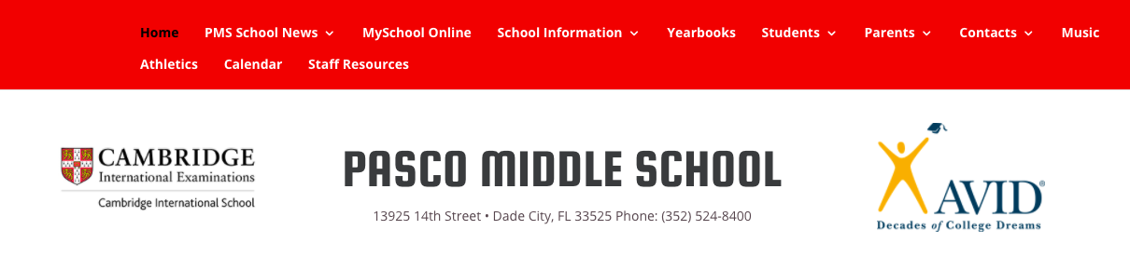

Here you will find the answers to other questions using the provided links.

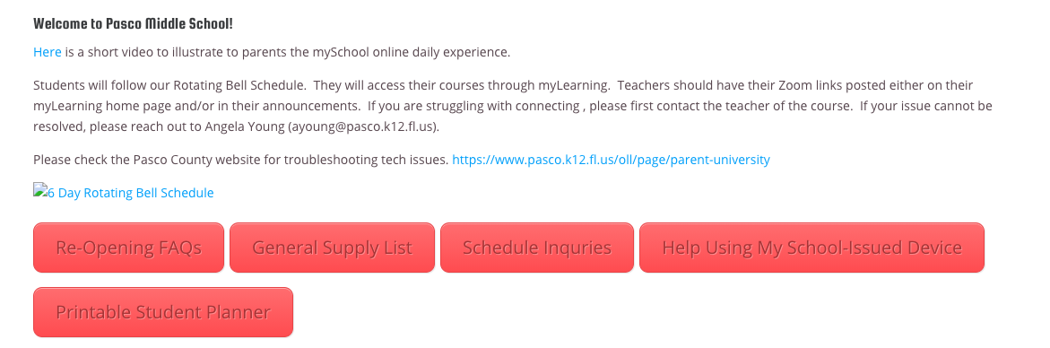

If you still have questions or cannot log into your classes, please call the school at 352-524-8400 and ask for Mrs. Young or Mrs. Tellez, they are both Assistant Principals. You can also email them at: ayoung@pasco.k12.fl.us, jtellez@pasco.k12.fl.us .

